Please register at: Lab registry

Laboratory Session – introduction to Matlab

For your AAI coursework on Neural Networks and Genetic Algorithms you will need to use Matlab platform. Most of the lab sessions are aimed at giving you the skills to successfully complete your coursework.
The aim of this lab session is to familiarize yourself with some of the basic functionalities of the Matlab software and its commands. Many of these commands will be useful to you – try your best to understand how they work and what they do before moving on to the next lab material.

Lab 1

Learning outcomes: After this session you will be able to use Matlab for simple matrix calculations, saving data to a file, and loading matrices from a file. You will learn some of the simpler capabilities of the Matlab package and will become familiar with the Matlab Help function. You will also learn how to draw simple plots using Matlab graphics capabilities.

Double click the Matlab icon (or go to Start/AppsAnyware/Matlab R2024a (Site)[Campus or VPN*] (make sure your VPN is on)) to get Matlab up and running. We will use the Matlab package and its toolboxes for the later lab sessions as well.
You can read the Help at a later date – for now we just want to use the command window and get Matlab to do some calculations and visualizations.

Please don’t forget to create a directory (on OneDrive, not on the desktop computer you are using), where to keep your files from each lab session (use folders such as ‘lab1’, ‘lab2’, etc.)!

All the instructions below refer to the command window. Just type them at the “>>” prompt.
What follows in bold italic (red colour), is what you should type (or copy/paste) at the command prompt. There may (or may not) be symbols in non-bold italic, following these input commands, that show the Matlab output. Sometimes the output you get will be different to what appears here (e.g., if there is some random process). Even if the output is given, you should still try the input command yourself (you may need your particular data output later).

We shall start with vectors and matrices manipulations, as you will need these later for your coursework.
You can use a ‘space’ or a ‘comma’ to separate the elements of a vector:
a = [-1 3 2]
a = [-1, 3, 2]

To transpose a vector (or to ‘rotate’ it from a ‘row’ to a ‘column’), use the ' symbol:
a'
You have two types of multiplication in Matlab: * - matrix multiplication and .* - array (element-by-element) multiplication:
If you try to multiply a*a it won’t work (why?):
a * a
Now, try:
a .* a (the result is the squared values of the elements, although, vector a will remain the same)
Try also:
a * a’ (this is , n=2 in this case – three elements in each vector, and the result is 14)
We can enter a matrix a (2x2 in this case) as follows and Matlab will respond:
a = [-1 3 ; 2 1]

Now enter:
b = [2 3 ; 0 4]

We want to check that Matlab knows how to multiply and add matrices correctly – enter the following commands and check the answers.
a+b
a * b

Let’s have a new matrix c (2 rows by 3 columns):
c = [1 2 3; 3 4 5]

Recall that we can't multiply matrices if they are incompatible in size. The general rule is to multiply a row (from the first one) by a column (of the second one) to receive an element of the resulting matrix.
Let’s try to multiply c*a (it won’t work, why?) :
c * a

We can get c' * a though:
c’ * a
(which should give you a 3x2 matrix [5 6; 6 10; 7 14]).

Try raising the matrix c elements to the power of 2:
c^2 (it won’t work, why?)

Now, try raising element-by-element – this has a . in front of the ^ operator:
c.^2 (now it should work!)

Try also:
a.*a and a.^3

Make sure you know what the difference between .* operator and just * operator is!
If you want to keep the result, you will need a variable name for the answer, e.g.:
y = c’ * a ([5 6; 6 10; 7 14]),

and now you can use y in a calculation:
y+[0 0; 1 1; 2 2] ([5 6; 7 11; 9 16]).

You will need to know how to transpose matrices
Y’

Y

y' ([5 6 7; 6 10 14] – from 3x2 it becomes 2x3 matrix).

So, the ‘transpose’ operation (') flips rows and columns. This is useful in situations where, e.g., Matlab function require parameters as a column vector, but our data is a row vector, etc.
If we want to add an additional column to an existing matrix we can do this as:
z = [y [2;3;4]] (this will give a matrix [5 6 2; 6 10 3; 7 14 4]).

Matlab programming language uses the assignment statement in the usual way:
a = a+b (you have to define b first, e.g., b=[2 2; -2 -2]; and then the result should be [1 5; 0 -1]).

Importing and exporting data:
The matrix a is not a large matrix – but in other cases it might be and we may need to save it to a file:
save data.txt a -ascii

This will save the matrix in a file data.txt (as ASCII). Look at this file to see what you have in it (give the full path when saving the file, if necessary).
Again, please keep your files from each lab session in folders such as ‘lab1’, ‘lab2’, etc.!

We can load files as well – be careful with the quote marks (‘) if you copy/paste the command.
z = load('data.txt')

There are also commands that read and write delimited text, if you want other than space delimiters:
dlmwrite('data2.txt',a,':')
Colon delimited files are used in some unix systems – it is more common to use commas or tabs on Windows systems.

There is a similar command dlmread which you can find out about using the Matlab help
help dlmread

Matlab Help will give you information about any command – just type help followed by the command:
help help

If you want to keep track of what you are doing, try the diary command (use Help to find out about it).
If you want to keep all your working, you can save the workspace as a .mat file – again see help on save for the details.

We are now going to create some data for future use.
Entering data by hand can be tedious, so Matlab allows creating uniformly spaced data points, e.g.:
a = 0: 0.1: pi

In a loop from 0 to π (~ 3.14), with step 0.1, this command will create 32 uniformly spaced real values in this interval (last one beeing 3.1), and they will be stored in vector a.
If you have a hundred (or more) data values for a vector (or matrix) and if you don't want them to show and fill up the screen, you can always use semicolon (;) at the end of the statement:
b = 0: 0.01: 1; (the values of b will not be displayed).

The effect of the semicolon at the end of a command line input is to suppress the output display.
The following command will square all values
of vector a and will store them in vector c:
c = a.^2

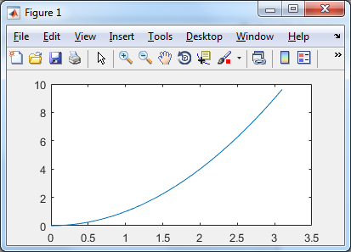Matlab comes with built in graphics capability
(useful for visualizing and investigating data):
plot(a,c)

This is what you should get (Fig.1):
(horizontal axis – values from 0 to 3.14;
and vertical axis – values from 0 to 10,
and the function c=f(a) displayed).

We are going to produce a matrix with more data.
Column 1 will be the argument values of the
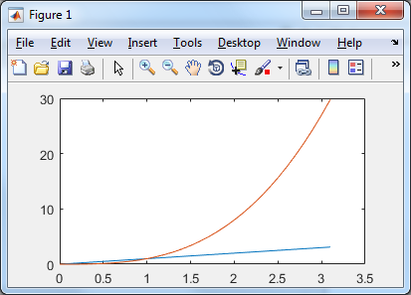datapoints (x axis) and the other columns will be the
various functions that we are interested in.
Let us practice first and find out what we shall get from:
d = a.^3;
e = a.^4;
f = sin(a);
data = [a' d']
plot(a', data)
(horizontal axis – values of a’; and then a’ and d’ displayed ).

Use the Help on plot to see the various variants of plotting.

plot(a,f)

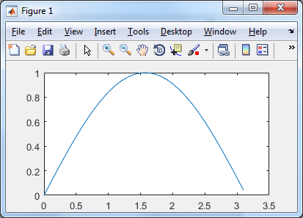We don't need our data to be ‘clean’ –
this wouldn't help when we later use it
for Neural Network (NN) training.
We will see how to create a 'noisy' data,
which could be useful for NN training and testing.
a = 0: 0.01: 2*pi;
b = a.^2;
c = a.^3;
d = a.^4;
e = sin(a);
f = 0.05*randn(size(a));
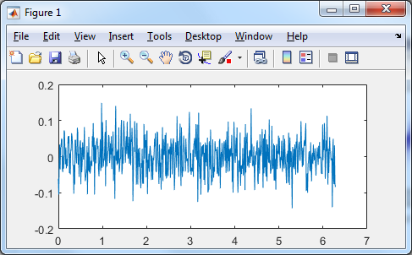
This last statement gives a random matrix
of the same dimensions as a (the 0.05 factor
is to make the random values small).
We won't actually use f right now, though,
you might want to look at it.

plot(a, f);
(for each of the 629 values of a,
a random value f will be plotted)

You can save this sequence of statements,
so that in later use, you don’t need to type it in again.
Type edit to open the MATLAB text editor:
edit
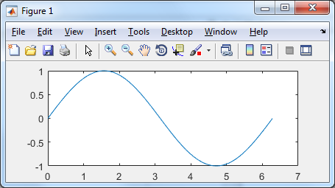Then copy and paste the sequence and save it as an .m file.
Now, visualise the sin() function:

plot(a, e);

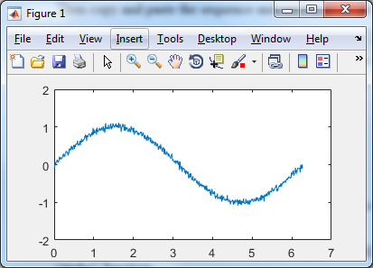To bring some ‘noise’ in it, we will use
the f vector (629 values).
Use the Help to read more about the randn() function:

plot(a, (e+f));

You can put all the above vectors into one matrix (what will be its size?):
data = [a' b' c' d' e'];

Now, we will save the matrix data, to use it later, with:
save data.txt data -ascii
Check the file to make sure the data is there – if you want to inspect it, use a spreadsheet (e.g., Excel). You will need this file later on, so make sure it's there.

Whenever you want to repeat a task many times, it is worth writing an m-file, to make your life easier.
Here is an example of an .m file, which contains a function definition. What does this function?
First, copy and paste the following source code into an .m file using from the EDITOR menu bar the ‘New -> Function’ option.
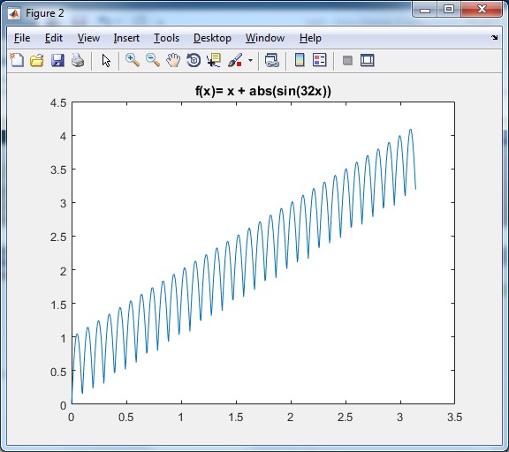
function f = xPlusAbsSin32x
x = 0: 0.005: pi;
f = x + abs(sin(32*x));
figure;
plot(x,f);
title('f(x)= x + abs(sin(32x))');
end
Save the file as ‘xPlusAbsSin32x’
(the .m extension is already given by MATLAB).

Select ‘Run’ to execute the function. Your m-file program will now run and you will see
this figure:

Do the same for the following function:

function ff= fun_with_noise
a = 0:0.01:2*pi;
b = a.^2;
c = a.^3;
d = a.^4;
e = sin(a);
f = 0.05*randn(size(a));
plot(a,f);% will plot the noise f(a)
(hold);
plot(a,e+f);% will plot sin(a) with noise
title('Function sin() with noise f(a)');
end
